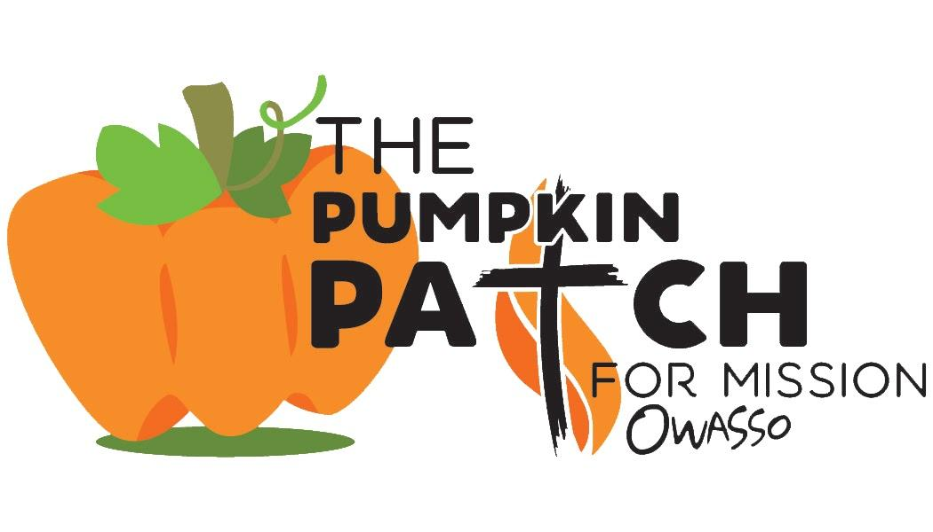

Pumpkin Patch for Mission 2017

The annual “Pumpkin Patch for Mission” will be sponsored at The First United Methodist Church of Owasso (FUMCO), October 5-31, 2017. Our pumpkin patch is unique in that ALL proceeds from pumpkin sales are given away to local, regional and global mission. Our mission is to offer a safe and fun fall activity for families and students to enjoy year after year while also funding local, regional and global mission!

Our pumpkins are born in New Mexico and transported to Owasso in tractor trailers. The pumpkins come from Pumpkins USA/Pumpkins Fundraising. They provide pumpkins to non-profit organizations for fundraising sales. Check out their website, https://www.pumpkinsusa.com/about-us/our-story and follow on Facebook.

Purchasing pumpkins at the patch makes a difference locally and globally. The 2016 Pumpkin proceeds allowed us to provide financial support or donated items to: Owasso Community Resources (OCR) http://owassohelps.org, Arubah Community Clinic in Collinsville http://arubahclinic.com, City Lights Foundation (sponsor of Night Light Tulsa) https://the-city-lights-foundation-of-oklahoma.networkforgood.com, FUMCO Food Pantry , FUMCO Christmas Everyday fund, Restore Hope Ministries, UMCOR relief kits, OKVIM ongoing Bolivia mission efforts, FUMCO sponsored VIM Mexico Spring Break mission trip, OKUMC sponsored Exodus House and CJAMM ministries, OCR sponsored Thanksgiving Baskets and Christmas Angel Tree gifts for CJAMM and children through OCR. Learn more about these mission at our website: http://fumcowasso.org/about/missions/.

Most importantly, the “Pumpkin Patch for Mission” is also an outreach to Owasso and the surrounding communities. The “Outdoor Classroom” provides a fun learning opportunity for school field trips. The annual “Hance Henrie Memorial Run for the Patch” start and finish line are at the Patch. A free outdoor movie night and the annual Halloween “Trunk or Treat” are also held at the patch.

This year the Patch will open on Thursday, October 5th. The hours are Sunday-Friday daily, from noon to dusk, and Saturdays and fall break (October 19-24) from 10 a.m.-dusk. In addition to the Pumpkins for sale – that come in a wide variety of shapes, sizes and colors - our activities include: Outdoor Classroom, weekend hayrides, a fun maze, stickers and wonderful photo backdrops.

We are also collecting NEW ADULT SOCKS of all colors to give to our friends at Night Light Tulsa in support of their month long SOCKtober initiative.

The event schedule includes:
October 13th- movie night “It’s the Great Pumpkin, Charlie Brown” in the patch
October 14th- 7th Annual “Hance Henrie Memorial Run for The Patch” http://fumcowasso.org/pumpkin-patch/run/
October 26th - Night Light Tulsa Pumpkin Night - we take the patch to downtown Tulsa and donate pumpkins to the Night Light community
October 31st- Trunk or Treat 6-8pm

The “Pumpkin Patch for Mission” is located at 13800 E 106th St N, Owasso, OK, 74055. For information and updates about our patch, its mission and outreach, patch activities and events at FUMCO, please visit : http://fumcowasso.org/pumpkin-patch/, FB or Instagram @Pumpkin Patch for Mission.

Pumpkin Patch for Mission 2017 Calendar of Events

October 5th-October 31st – Open Daily, NEW Adult Socks donations for Night Light Tulsa accepted
Sunday-Friday- Noon-dusk
Saturday and Fall Break (October 19-24) - 10 a.m.-dusk
For information visit: http://fumcowasso.org/pumpkin-patch/ and find us on FB and Instagram.

October 5th-October 31st - Outdoor Classroom
Most Tuesdays, Thursdays and Fridays in October
Our Outdoor Classroom is a free learning opportunity available to
area schools for field trips. Some additional projects may have a minimal fee for supplies. For information visit: http://fumcowasso.org/pumpkin-patch/.

Friday, October 13 - Free Movie Night in the Patch
Dusk - Bring your lawn chair and blankets and join us in watching
“It’s the Great Pumpkin, Charlie Brown” in the patch. For information visit our website: http://fumcowasso.org/pumpkin-patch/ and find our event on our FB page.

Saturday, October 14 - 7th Hance Henrie Memorial Run for The Patch
Registration begins at 7:00 AM
Fun Run at 8:00 AM
5K, 10K and Great Pumpkin Challenge (15K) at 9:00 AM
USATF Certified and Sanctioned Course, Chip Timed
For more information and to register online visit: http://fumcowasso.org/pumpkin-patch/run/ and their FB page.

Thursday, October 26 - Night Light Tulsa Pumpkin Night
5:45 p.m. - Meet at FUMCO east building entrance to caravan with
us to Night Light Tulsa.
6:30 p.m. - If not joining us for the caravan, meet us under the
bridge, Brady and Maybelle, 202 N. Maybelle, to serve the Night Light community
Pumpkin Patch proceeds are sponsoring the weekly dinner at Night Light Tulsa and the patch is donating pumpkins for the Night Light community. Learn more about Night Light Tulsa at: http://www.nightlighttulsa.org/about and their FB page.

October 31 - Trunk or Treat
6pm to 8pm Come trick-or-treat in a safe environment. Walk from trunk to trunk of vehicles filled with spooks and surprises! Plenty of candy to go around for everyone! No need to hurry through dinner – we’ll have it ready when you arrive. Free hot dogs and hot chocolate! For more information visit: http://fumcowasso.org/pumpkin-patch/ and find our event on our FB page.

