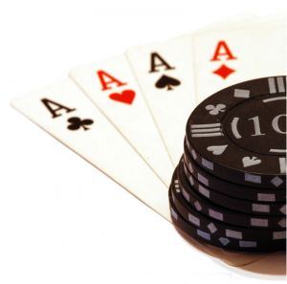
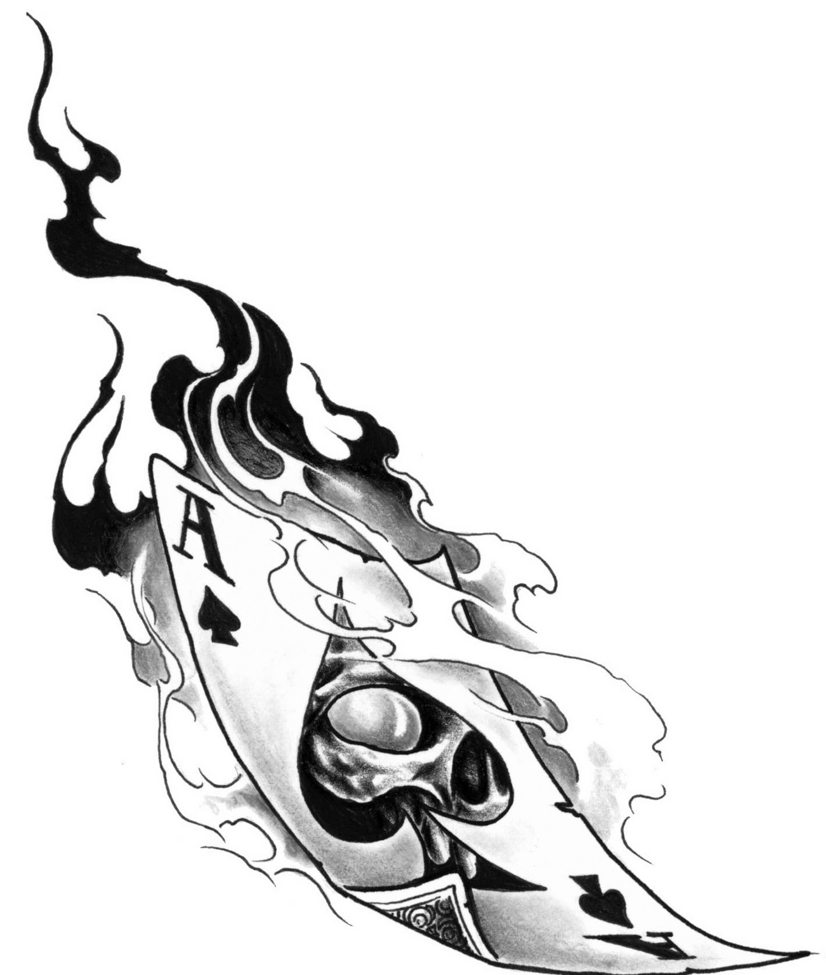
The Rock Gym in Collinsville Presents….
“Know When To RUN…” Evening 5K Poker Run
& 1 Mile Fun Run

7pm Kids Fun Run & 7:30pm 5K Poker Run
$25 Pre Register or $30 Race Day Reg

LOTS OF GREAT PRIZES!!
1ST Place Girl and Boy in Fun Run Get a BIKE!!
Prizes for BEST HAND
Prises for Overall BEST TIMES
Medals for Top 3 of Age Groups

AFTER PARTY TBA

1 Mile Fun Run will begin at 7pm. 1st place Boy & Girl will each win a new BIKE!
The 5K Poker Run will start at 7:30pm. Timing will be done by Tatur Racing! Racers will pick up cards at designated “Dealers” along the race route. At the end of the race, the overall BEST hand will win the GRAND PRIZE! There will also be prizes awarded to FASTEST FINISHERS of the 5K!
There will FUN for EVERYONE! Get out and get your RUN ON!

